Chapter 4, Problem 31.

Determine v_{x} in the circuit of Fig. 4.99 using source transformation.

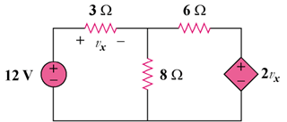

Figure 4.99
For Prob. 4.31.

